The Clallam Literacy Council “Write To Win A Tablet” Contest Entry Form
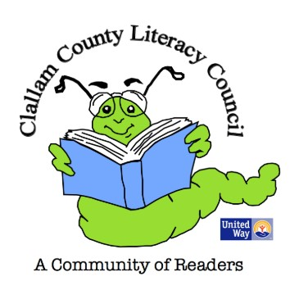
NAME________________________________________Age_______________
CONTACT INFO: (address, email, phone #) _____________________________________________________________
_______________________________________________________________
Answer 1 of these questions:
1. “If I could read better, I would read…..”
2.“Because I am learning to read better, I will be able to….”
3.The best thing I have ever read was……”
Do your best to describe what is in your heart when you think about one of these questions. Don’t worry about spelling or punctuation. Just write what you feel. Please use the back if you need more writing space.

________________________________________
Signature
You may also enter by mail. Be sure to include your age, contact information, and answer one of the questions and mail it to United Way of Clallam County, P.O. Box 937, Port Angeles, WA 98362. Contest open to children aged 6-18. The contest runs through July 31st and winners will be announced on August 15. For more information, call the United Way office at (360) 457-3011

